- In MS Word go to the developer tab and click on Record Macro
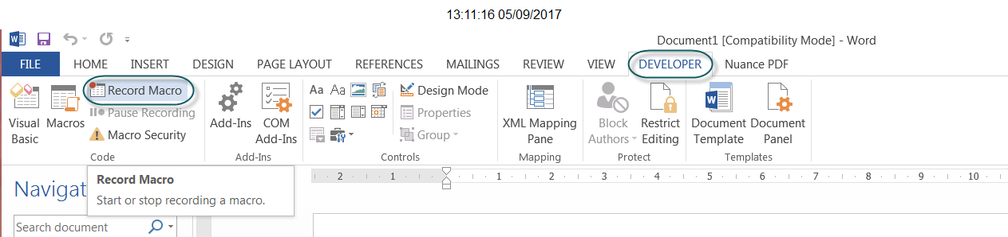

- Insert a name for the macro (no spaces) and under ‘Assign Macro to’ click on Button
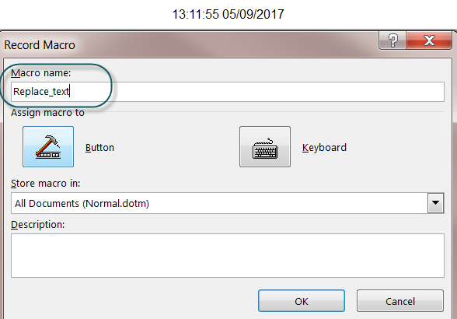

- A pop up window will appear. Find your new macro in the left hand box, highlight and click on Add.
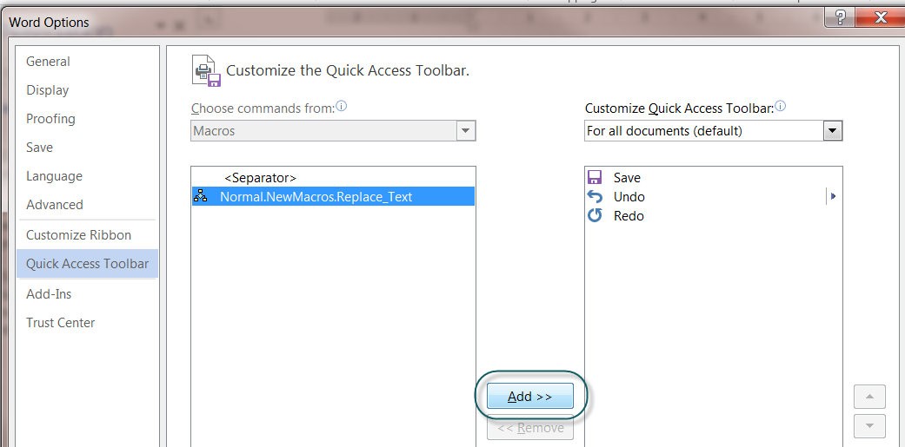

- Press CTRL and F keys together to open the find and replace function. In the Navigation box on the left hand side of the page click on the downward arrow and select ‘Replace’.

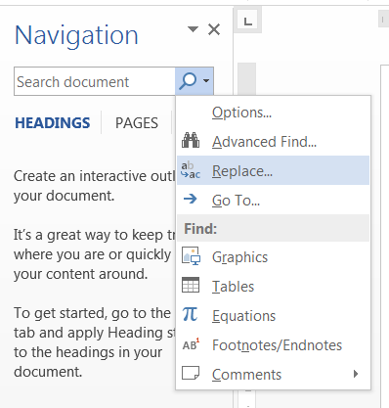

- Enter the details to be replaced as required.
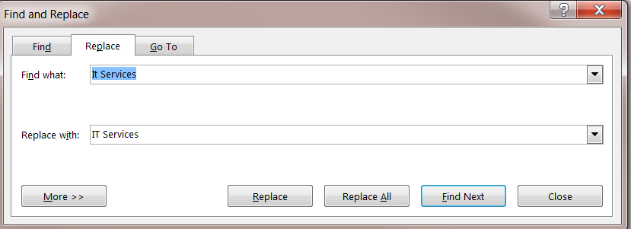
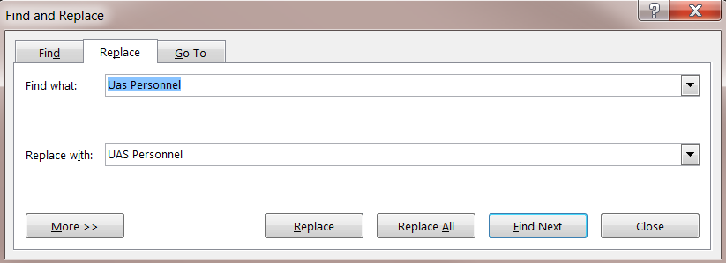

- In the ‘Developer’ tab click on Stop Recording.
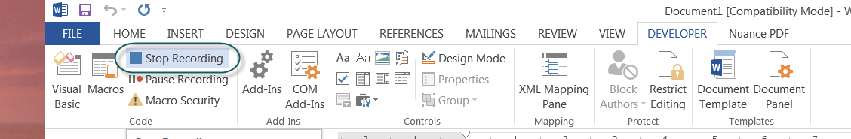

- A shortcut to the macro should now appear in ribbon at the top of your screen. From now on whenever you need to find and replace the text in a document, click on this button. All text will be searched for and replaced as stipulated in the macro.

